## Protecting Data with Azure Backup

Lab Overview

In this lab, you will protect a virtual machine using Azure Backup.

### Exercise 1: Creating an Azure Backup Vault

In this exercise, you will create an Azure Backup Vault in your Azure subscription by using the Microsoft Azure Management Portal.

1. Logon to https://portal.azure.com.

1. Click on the **+NEW** icon at the upper-left corner of the dashboard menu. In the **Search the marketplace** box, type in **OMS** and hit **[ENTER]** to display the results. Select **Backup and Site Recovery (OMS)** from the **Everything** blade.

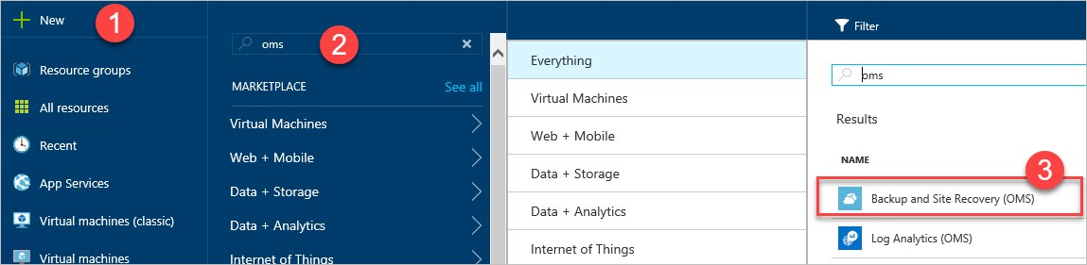

1. Click the **Create** button on the **Backup and Site Recovery (OMS)** information blade to continue.

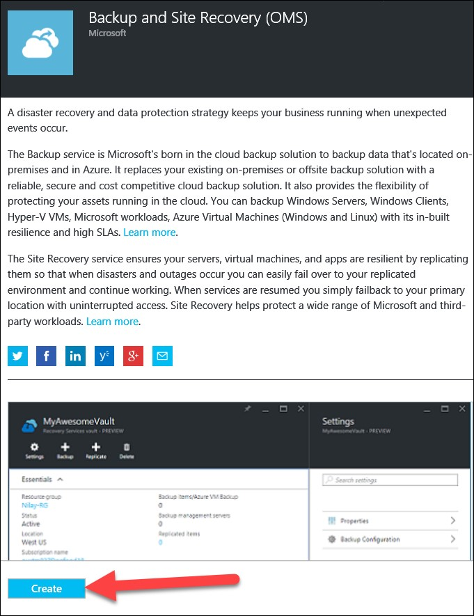

1. Enter the following information to create the vault:

* 1. Name: **OpsDemoBackupVault**
  2. Subscription: **Your subscription**
  3. Resource Group: **Create new** with name **OpsVaultRG**
  4. Location: **Make sure this is the same location where existing VMs were created, such as LABVM.**
  5. Pin to dashboard: **Check the checkbox**
  6. Click the **Create** button

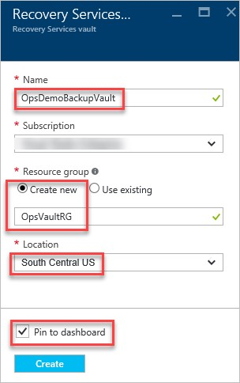

NOTE: Do not continue until the portal provides confirmation that your Backup Vault has been created.

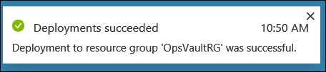

### Exercise 2: Registering an Azure Virtual Machine to Backup using Azure Backup

1. From the Microsoft Azure management portal at https://portal.azure.com, click on **OpsDemoBackupVault** that was pinned to the dashboard earlier.

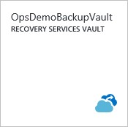

1. In the **Settings** blade, under **GETTING STARTED**, click the **Backup >** option.

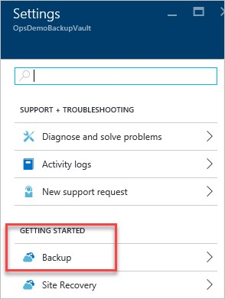

NOTE: Alternately, you can choose the +Backup icon in the top options of the vault information blade as well.

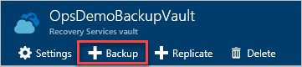

1. In the resulting blade, **Getting started with backup**, for selection **1 Backup goal**, choose **Azure** as the workload and **Virtual machine** for the what to backup.

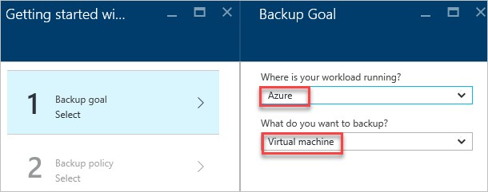

1. Click on the **OK** button at the bottom of the dialog to continue.

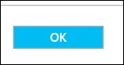

1. 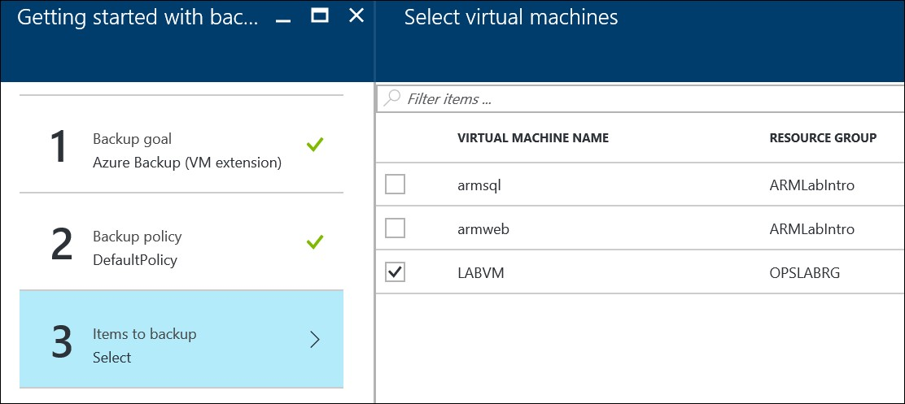For step **2 Backup policy**, leave everything at the **DefaultPolicy** option for this exercise.

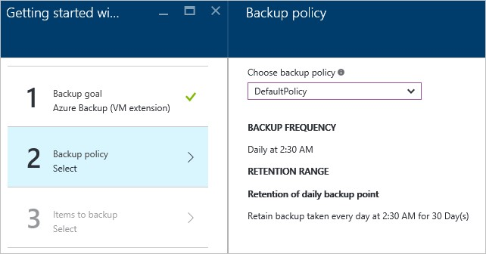

NOTE: If this were a production environment, you could create a new Backup Policy at this point should the need arise.

1. Click on the **OK** button at the bottom of the dialog to continue.



1. In step **3 Items to backup**, you should see **LABVM** in the **Select virtual machines** blade. Click the checkbox to place a checkmark in the box beside **LABVM**, then click the **OK** button at the bottom of the window.

NOTE: If you do not see any VMs to choose in this blade, you probably deployed either the VM or the Vault in different regions. The VMs have to be in the same location as the Vault for them to appear in this list.

1. After clicking **OK**, click the **OK** button on the **Getting started with backup** blade to continue.

1. On the **OpsDemoBackupVault** overview page, you can view the **Backup Jobs** tile to monitor progress.

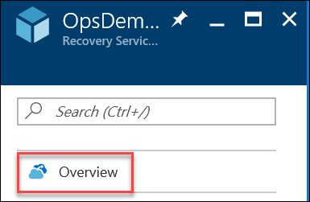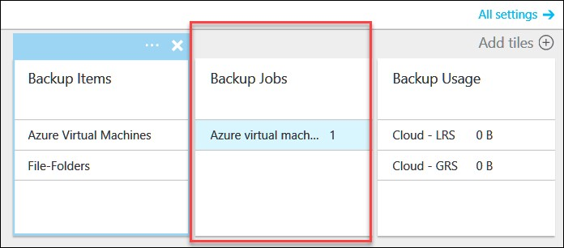

1. Click on the **Backup Jobs** tile to view the job progress. This is the job to configure the VM for backup and should complete relatively quickly. Wait until the **STATUS** shows **Completed** before continuing.



1. Exit the **Backup Jobs** blade back to the **OpsDemoBackupVault** information blade. You should now see a **1** under the **Backup items** tile.

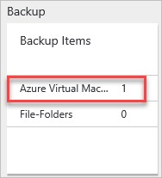

1. Click on **Azure Virtual Machines** on the **Backup Items** Tile and in the resulting Backup Items blade, you will see **LABVM** listed

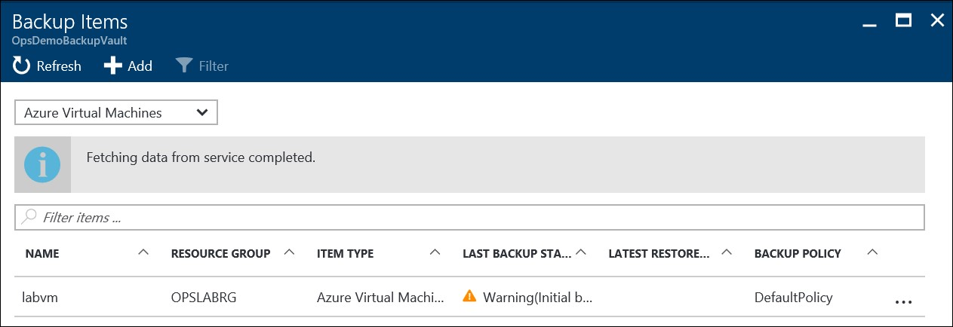

NOTE: In the drop-down list, you can choose between Azure Virtual Machines or File Folders in this listing to view either.

1. Click **LABVM** to open the information regarding this VM. At the top of the page, click the **Backup now** icon to start a manual backup for this VM. Click Backup on the **Backup Now** blade

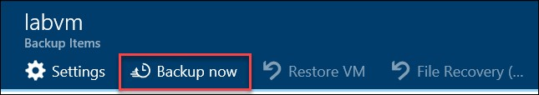

1. On the **Backup now** blade, notice the **Retain Backup Till** date is 30 days from the current date, corresponding to the DefaultBackupPolicy.Click **Backup** at the bottom of the blade. **This** will trigger a backup job and provide notification that the backup has been triggered.

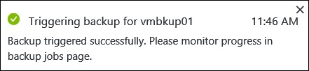

1. Next, use the bread crumb menu to go back to the information blade for the

**OpsDemoBackupVault** and notice the **JobsCount** in the **Backup Jobs** shows a job is running.

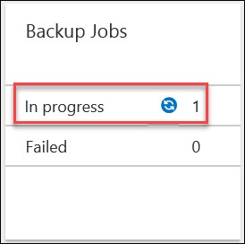

1. Click on the **Backup Jobs** Tile to monitor the job. You should see the **OPERATION** of **Backup** for **LABVM** is now **In progress**.



### Exercise 3: Confirm Backup Extension Provisioned Successfully

1. Once the backup has started and is **In progress**, wait a few minutes and then browse to the VM settings by clicking on **Virtual Machines** in the left hand menu of the Azure Portal.



1. Click on **LABVM** in the list of VMs.

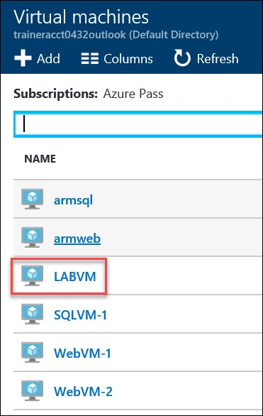

1. Once the information blade is displayed, in the **Settings** blade, click on **Extensions >** under the **SETTINGS** section.

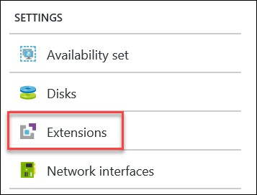

1. Take note that the **VMSnapshot** extension has been provisioned successfully allowing Azure Backup to occur on this VM. There is a similar extension should you be backing up a Linux VM as well.

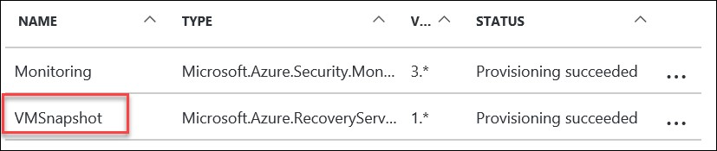

### Lab Summary

In this lab, you provisioned a virtual machine via Azure Resource Manager Portal using the image gallery. Next, you used the created an Azure Backup Vault in the ARM Portal and registered the newly deployed VM to be backed up to the vault. You then manually started a backup and confirmed the backup extension was installed and successfully backed up the VM.